**(Precision Full Wave Rectifier)**

Laboratory Project Report submitted for

**Design with Analog Integrated Circuits**

**(EET3131)**

Submitted by

**Siddharth Sahu-1541016239**

**Satyabrat Sahoo-1541016245**

**Chandra Akash-1541016252**

**(ECE-A,5th semester)**



Department Of Electronics & Communication Engineering

Institute of Technical Education and Research

(Faculty of Engineering)

**SIKSHA ‘O’ ANUSANDHAN UNIVERSITY**

Bubaneswar, Odisha, India

(November, 2016)

# Abstract

A **rectifier** is an electrical device that [converts](https://en.wikipedia.org/wiki/Electric_power_conversion) [alternating current](https://en.wikipedia.org/wiki/Alternating_current) (AC), which periodically reverses direction, to [direct current](https://en.wikipedia.org/wiki/Direct_current) (DC), which flows in only one direction. The process is known as [*rectification*](https://en.wiktionary.org/wiki/rectification), since it "straightens" the direction of current. Physically, rectifiers take a number of forms, including [vacuum tube](https://en.wikipedia.org/wiki/Vacuum_tube) [diodes](https://en.wikipedia.org/wiki/Diode), [mercury-arc valves](https://en.wikipedia.org/wiki/Mercury-arc_valve), stacks of copper and selenium oxide plates, [semiconductor diodes](https://en.wikipedia.org/wiki/Semiconductor_diode), [silicon-controlled rectifiers](https://en.wikipedia.org/wiki/Silicon-controlled_rectifier) and other silicon-based semiconductor switches. Historically, even synchronous electromechanical switches and motors have been used. Early radio receivers, called [crystal radios](https://en.wikipedia.org/wiki/Crystal_radio), used a "[cat's whisker](https://en.wikipedia.org/wiki/Cat%27s-whisker_detector)" of fine wire pressing on a crystal of [galena](https://en.wikipedia.org/wiki/Galena) (lead sulfide) to serve as a point-contact rectifier or "crystal detector".

Rectifiers have many uses, but are often found serving as components of DC [power supplies](https://en.wikipedia.org/wiki/Power_supplies) and [high-voltage direct current](https://en.wikipedia.org/wiki/High-voltage_direct_current) power transmission systems. Rectification may serve in roles other than to generate direct current for use as a source of power. As noted, [detectors](https://en.wikipedia.org/wiki/Detector_(radio)) of [radio](https://en.wikipedia.org/wiki/Radio) signals serve as rectifiers. In gas heating systems [flame rectification](https://en.wikipedia.org/wiki/Flame_rectification) is used to detect presence of a flame.

Because of the alternating nature of the input AC sine wave, the process of rectification alone produces a DC current that, though unidirectional, consists of pulses of current. Many applications of rectifiers, such as power supplies for radio, television and computer equipment, require a *steady* constant DC current (as would be produced by a [battery](https://en.wikipedia.org/wiki/Battery_(electricity))). In these applications the output of the rectifier is smoothed by an [electronic filter](https://en.wikipedia.org/wiki/Electronic_filter), which may be a capacitor, choke, or set of capacitors, chokes and resistors, possibly followed by a voltage regulator to produce a steady current.

More complex circuitry that performs the opposite function, converting DC to AC, is called an [inverter](https://en.wikipedia.org/wiki/Inverter_(electrical)).

# Contents

|  |  |  |  |
| --- | --- | --- | --- |
| **Serial No.** | **Chapter No.** | **Title of the Chapter** | **Page No.** |
|  | 1 | Introduction |  |
|  | 2 | Need Recognition and Problem Deﬁnition |  |
|  | 3 | Function Decomposition |  |
|  | 4 | Concept Generation |  |
|  | 5 | Concept Selection |  |
|  | 6 | Analysis |  |
|  | 7 | Testing and Improvement |  |
|  | 8 | Discussions and Conclusion |  |
|  |  | References |  |
|  |  | Appendices |  |

# 1 Introduction

A Full Wave Rectifier is a circuit, which converts an ac voltage into a pulsating dc voltage using both half cycles of the applied ac voltage. It uses two diodes of which one conducts during one half cycle while the other conducts during the other half cycle of the applied ac voltage.The precision rectifier, also known as a super diode, is a configuration obtained with an operational amplifier in order to have a circuit behave like an ideal diode and rectifier. It is useful for high-precision signal processing.op-amp-based precision rectifier should not be confused with the power MOSFET-based active rectification ideal diode.

**2 Need Recognition and Problem deﬁnition**



The signal processing applications with very low voltage, current and power levels require rectifier circuits. The ordinary diodes cannot rectify voltages below the cut-in-voltage of the diode. A circuit which can act as an ideal diode or precision signal – processing rectifier circuit for rectifying voltages which are below the level of cut-in voltage of the diode can be designed by placing the diode in the feedback loop of an op-amp.

**3 Function Decomposition**







**4 Concept Generation**



An ordinary rectifier can not be used in high precision rectification applications like the signal used in medical instrumention where the signals sensed through electrodes or other transducers are less than , say 0.7v in amplitude. Precision rectifiers are a boon in such a situation. It can pass the rectified signal to the output without the forward drop of the diode significantly affecting the reading.

 Then Why it is called as ‘Precision Rectifier’? Because it generates accurate output which is missing in normal rectifier circuit or power-supply rectifier circuit (rectifier circuit using diode).

theoretical and practical analysis, we have observed that for practical diode there is a voltage drop (Vd). It varies from 0.4 V to 0.7 V (approximately). This voltage drop effects the output voltage significantly. Sometimes output voltage increases or decreases from the desired level for this voltage drop. But it is not the case for Precision Rectifier. It generates accurate desired output

This rectifier uses ‘Super Diode’. A ‘Super Diode’ is a circuit combination of Op amp and diode. Diode rectifies the input, generates the output and OP amp reduces the voltage drop of diode (Vd) to zero (approximately). Thus, basically it works and generates the accurate output.

Another drawback of normal rectifier is it can’t generate output for a very weak signal. If the signal voltage is less than diode’s cut in voltage, the diode will be in cut off mode and no output will be generated. But Precision Rectifier is able to generate output for weak signal because Op amp has a very large gain. So, it can boost a weak signal to a sufficient level where it can drive a diode into forward biased condition.Hence we use precision full wave rectifier in order to get the desired output.

**5 Concept Selection**



**6 Analysis**

In precision fullwave rectifier for both the half cycles output is produced & in one direction only. The diagram below shows an inverting type of Precision FWR with positive output. It is also called as absolute value circuit because output signal swing is only in positive direction. So we get absolute value of input signal.

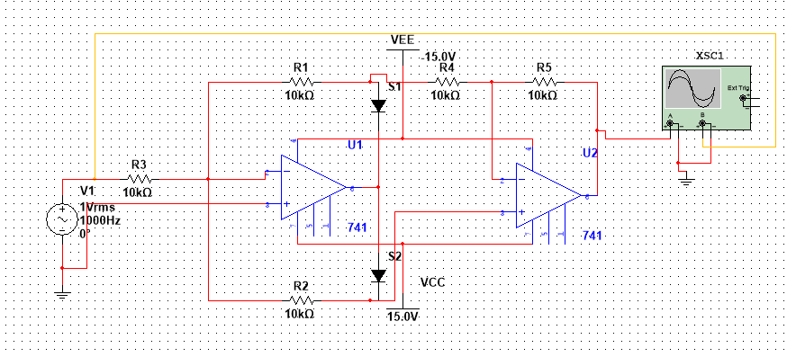

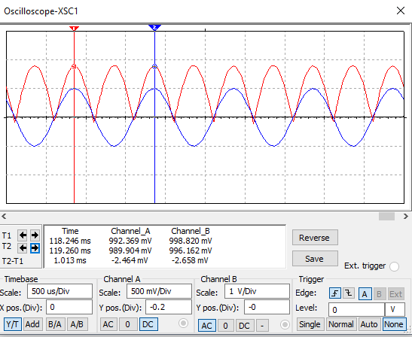

In positive half cycle of applied ac input signal, output of first op-amp (A1) is Negative. Therefore diode D2 is forward biased & diode D1 is reverse biased. Here op-amp A1 works as an inverting amplifier with gain =(-R1/R3)=-1.

Therefore output of op-amp A1 is ,V=(-1) Vin=-Vin  
Op-amp A2 works as an inverting adder. The two inputs to the op-amp A2 are voltage V (output of A1) and input voltage Vin. Thus output of op-amp A2i.e. Output voltage is given as

∴Vo=-[R/R Vin+R/(R⁄2) V ]  
∴Vo=-[Vin+2V]  
Substituting V=-V_in  
∴Vo=Vin

In negative half cycle of applied ac input signal, output of first op-amp (A1) is positive. Therefore diode D2 is reversed biased & diode D1 is forward biased.  
Due to virtual ground concept output of op-amp A1is zero. (∴V=0)  
Thus output of op-amp A2, i.e. Output voltage is given as  
∴Vo=-[R/R Vin+R/(R⁄2) V ]  
∴Vo=-[R/R Vin+R/(R⁄2) (0) ]  
But in negative half cycle input magnitude is negative therefore we get,

∴Vo=-[R/R (-Vin ) ]  
∴Vo=Vin  
Thus in both the half cycles output is positive & in one direction & also have same magnitude. Thus it is also called as non-saturating type of PFWR because op-amp A1 is not going in saturation.  
The transfer characteristics and input-output waveforms of PFWR are shown below,

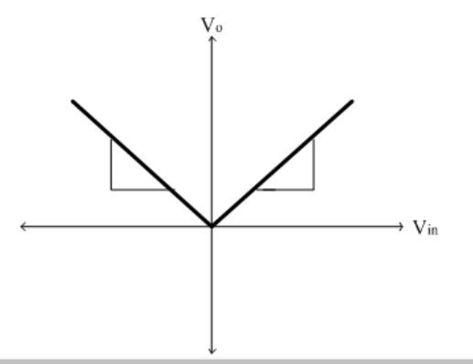

**7 Testing and Improvement**

**8 Discussions and Conclusion**

This rectifier uses ‘Super Diode’. A ‘Super Diode’ is a circuit combination of Op amp and diode. Diode rectifies the input, generates the output and OP amp reduces the voltage drop of diode (Vd) to zero (approximately). Thus, basically it works and generates the accurate output.

Another drawback of normal rectifier is it can’t generate output for a very weak signal. If the signal voltage is less than diode’s cut in voltage, the diode will be in cut off mode and no output will be generated. But Precision Rectifier is able to generate output for weak signal because Op amp has a very large gain. So, it can boost a weak signal to a sufficient level where it can drive a diode into forward biased condition. It has low ouput impdedance.And also Precision rectifier is a close approximation of an ideal diode because of absence of forward voltage drop.

 There are also disadvantages for Precision Rectifier

1. If input voltage exceeds power supply voltage of Op amp, the output will be saturated and we will not get accurate output.
2. This circuit has limitations for high frequency signals.

**References**

[www.circuitstoday.com](http://www.circuitstoday.com)

[www.wikipedia.com](http://www.wikipedia.com)

[www.electronicstutorials.org](http://www.electronicstutorials.org)

[www.allsyllabus.com](http://www.allsyllabus.com)

Design of analog integrated circuits using operational amplifier,3rd edition

**Appendices**

